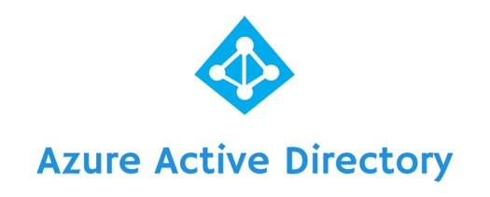

Created by: **Swapnil Ramesh Wadkar**

Contents

What is Azure Active Directory? 4

Benefits of Azure AD: 5

How Azure AD connect works? 6

Steps to perform: 7

1. CREATION OF THE DIRECTORY IN THE PORTAL 7

2. creation of sync account 7

3. downloading and configuring Azure AD Connect 7

4. azure ad connect upgrade 7

Let’s get started: 8

Creation of the Directory in the portal 8

Creation of sync account 16

Downloading and configuring Ad connect 20

Powershell Commands: 44

Azure AD connect Upgarde 45

References 59

# What is Azure Active Directory?

Azure Active Directory (Azure AD) is Microsoft’s multi-tenant cloud based directory and identity management service.

For application developers, Azure AD lets you focus on building your application by making it fast and simple to integrate with a world class identity management solution used by millions of organizations around the world.

Azure AD also includes a full suite of identity management capabilities including multi-factor authentication, device registration, self-service password management, self-service group management, privileged account management, role based access control, application usage monitoring, rich auditing and security monitoring and alerting. These capabilities can help secure cloud based applications, streamline IT processes, cut costs and help ensure that corporate compliance goals are met.

Additionally, with some simple steps, Azure AD can be integrated with an existing Windows Server Active Directory, giving organizations the ability to leverage their existing on-premises identity investments to manage access to cloud based SaaS applications. ***[Source: Microsoft]***

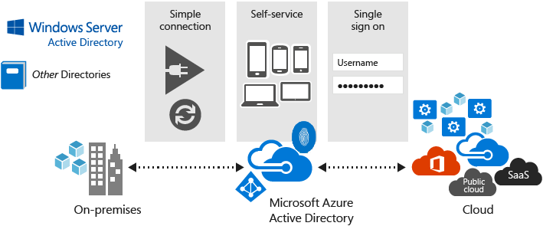

Figure Azure AD architecture

# Benefits of Azure AD:

Your organization can use Azure AD to improve employee productivity, streamline IT processes, improve security and cut costs in many ways:

* Quickly adopt cloud services, providing employees and partners with an easy single-sign on experience powered by Azure AD’s fully automated SaaS app access management and provisioning services capabilities.
* Empower employees with access to world class cloud apps and self-service capabilities from wherever they need to work on the devices they love to use.
* Easily and securely manage employee and vendor access to your corporate social media accounts.
* Improve application security with Azure AD multifactor authentication and conditional access.
* Implement consistent, self-service application access management, empowering business owners to move quickly while cutting IT costs and overheads.
* Monitor application usage and protect your business from advanced threats with security reporting and monitoring.
* Secure mobile (remote) access to on-premises applications. ***[Source: Microsoft]***

# How Azure AD connect works?

Azure Active Directory Connect is made up of three primary components: the synchronization services, the optional Active Directory Federation Services component, and the monitoring component named Azure AD Connect Health.

DirSync and Azure AD Sync are the older identity synchronization tools which are deprecated now. DirSync were offered for the single forest customers whereas customers with multi-forest and advanced topologies are offered Azure AD Sync. Now these two solutions are replaced by a single solution knows as Azure AD connect which contain DirSync, Azure AD Sync and FIM + Azure AD connector as a Sync Services.

Additionally, it also contains ADFS and Health monitoring solution which provides easy cloud based approach to gain insights and monitor on premises identity infrastructure which is used to access Office 365 and other Azure AD applications with simple installation of agent on each of on premises identity servers

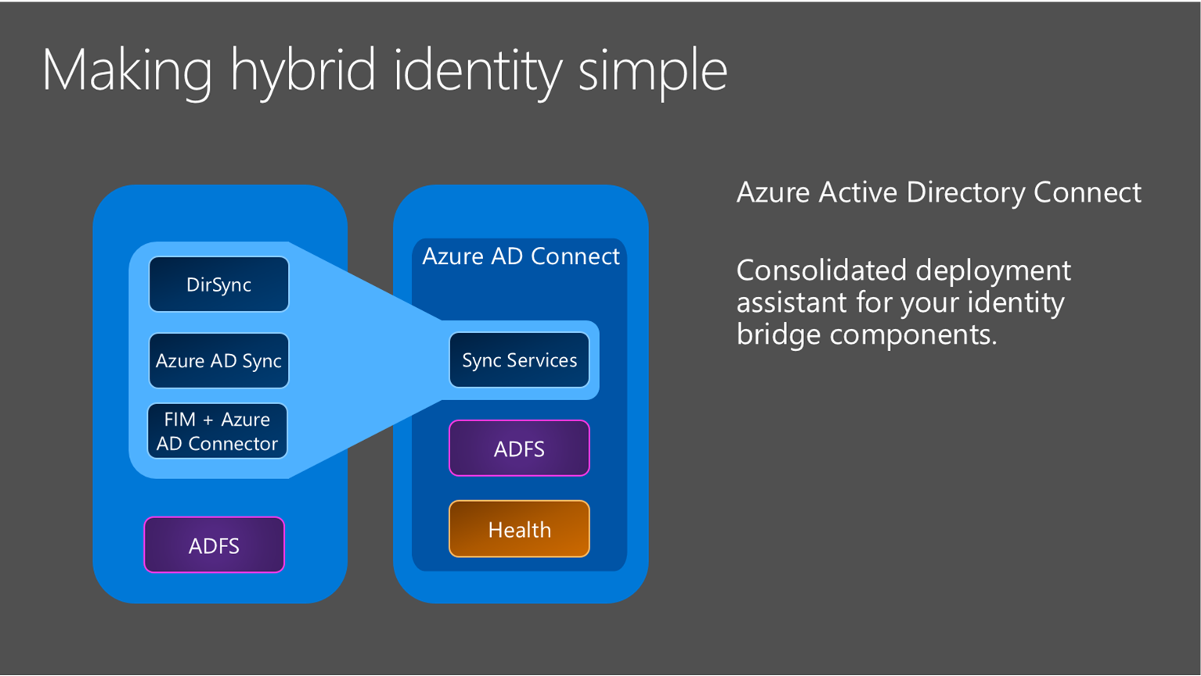

Figure Azure AD connect components [source: Microsoft]

# Steps to perform:

For installation of Azure AD connect, 3 steps are required.

## CREATION OF THE DIRECTORY IN THE PORTAL

## creation of sync account

## downloading and configuring Azure AD Connect

## azure ad connect upgrade

We will follow these steps and configure Azure AD connect.

# Let’s get started:

## Creation of the Directory in the portal

Login to <https://portal.azure.com>

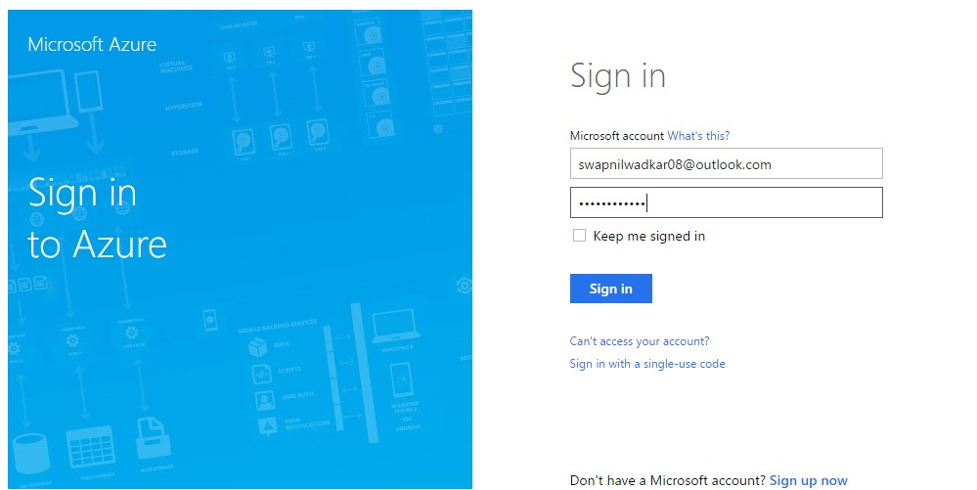

Select the proper directory in which your subscription resides. Remember, directory can have many subscription

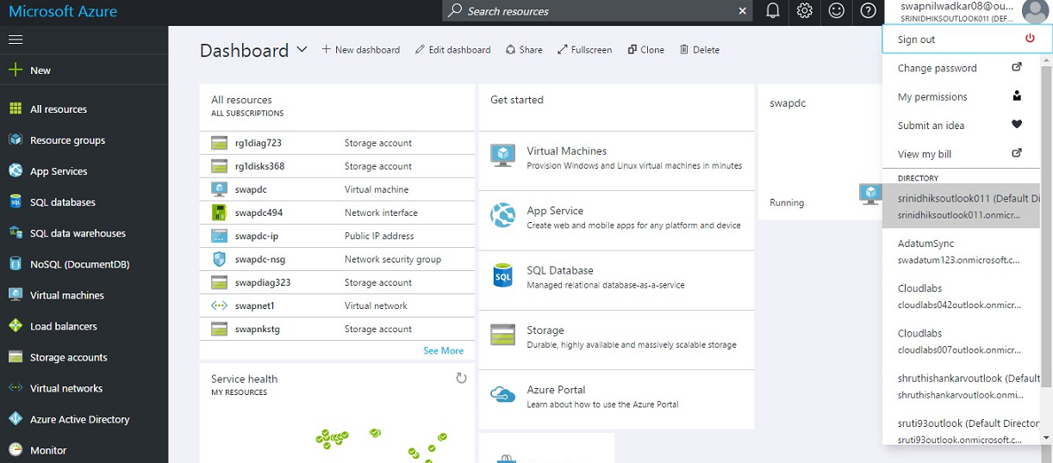

In Azure market place, search for “**Active Directory**”

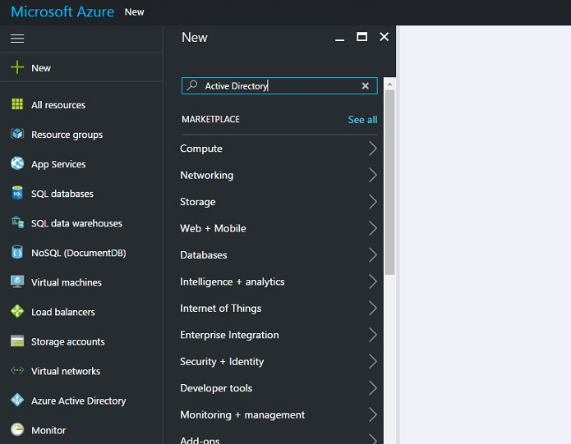

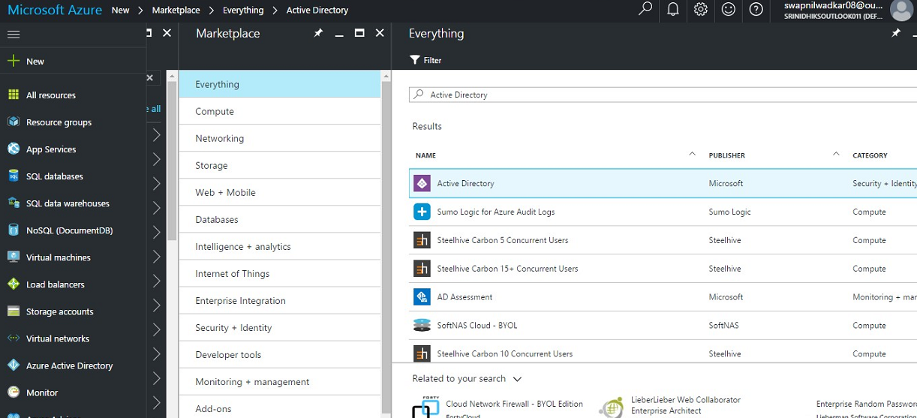

Click “***CREATE***” and you will be redirected to Azure old management portal since Azure AD is still not supported in new portal <https://manage.windowsazure.com> .

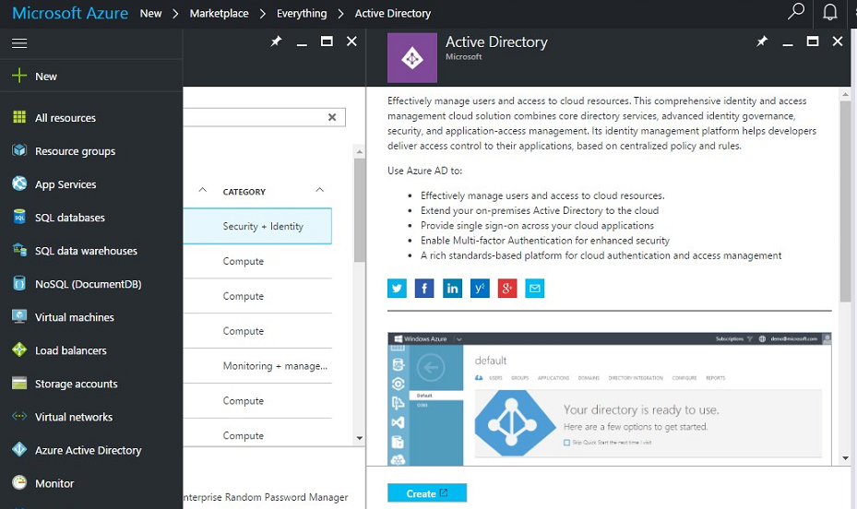

In “**Active directory**” option, add a new directory by clicking “**New**” at the bottom right , create with your domain name

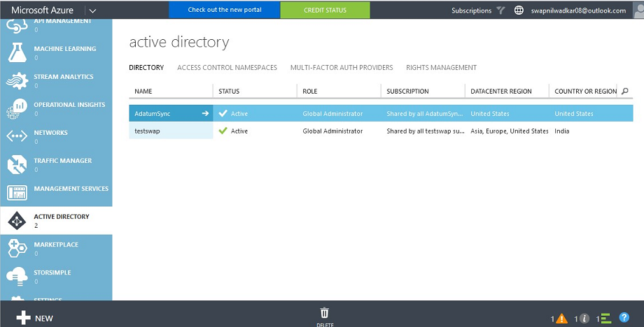

Select the “**Directory**”

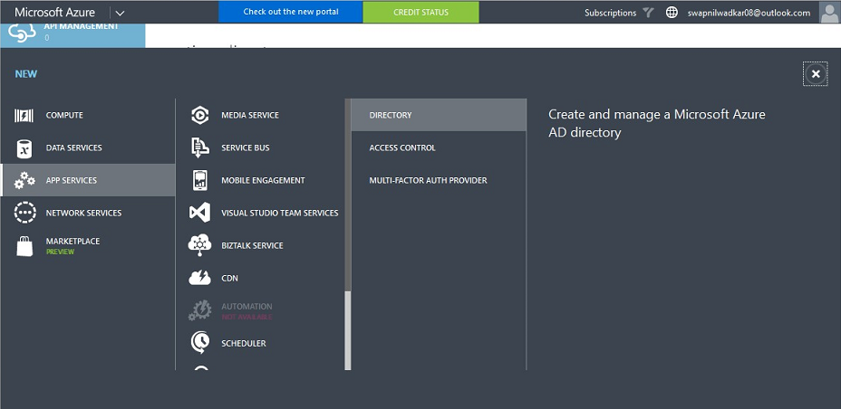

Click “**Custom Create**” option to create a new directory

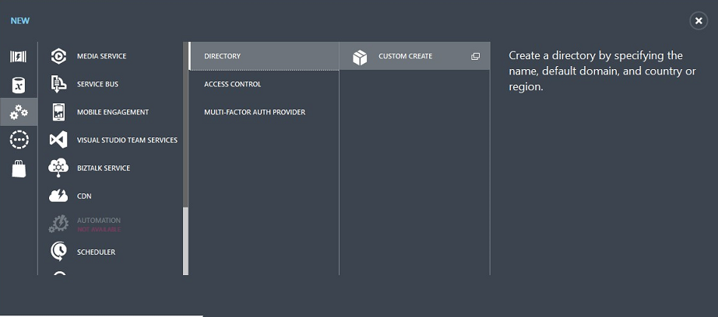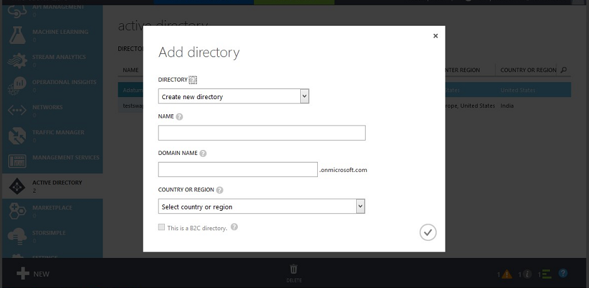

Fill the required detail like name of the directory and domain name and click OK

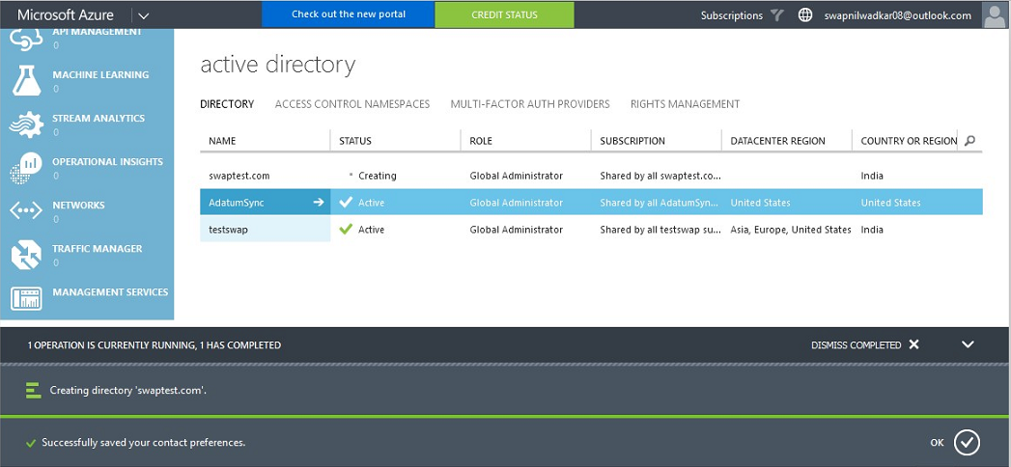

Select the newly created directory

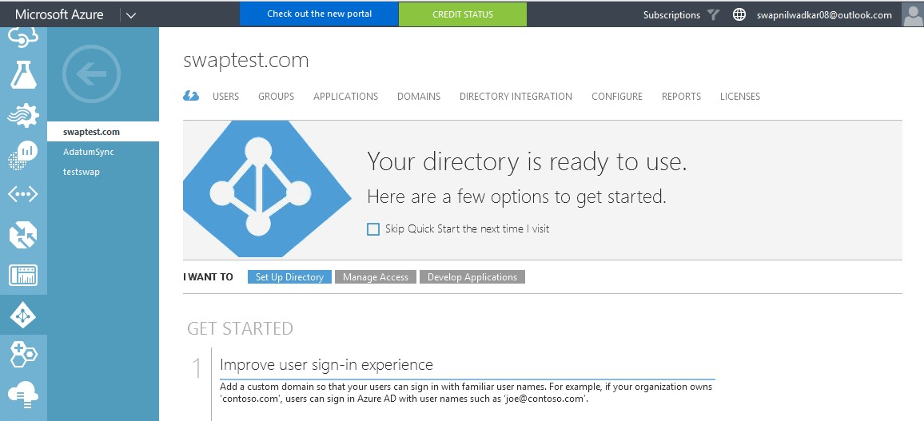

## Creation of sync account

In Users tab, create a new global administrator by clicking the “**Add User**” option at the bottom.

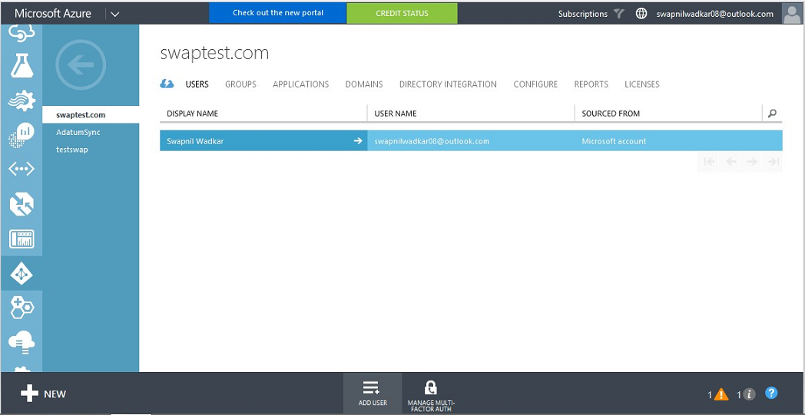

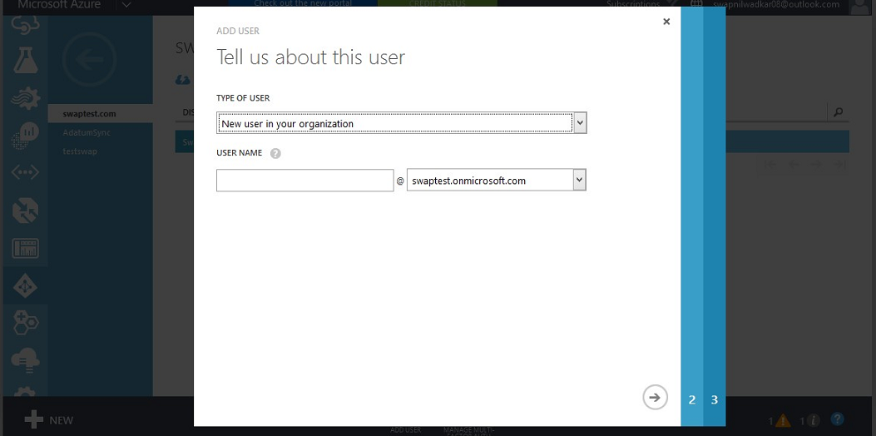

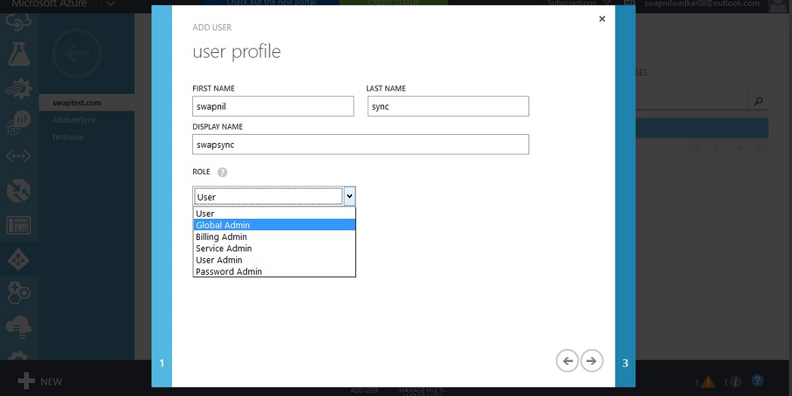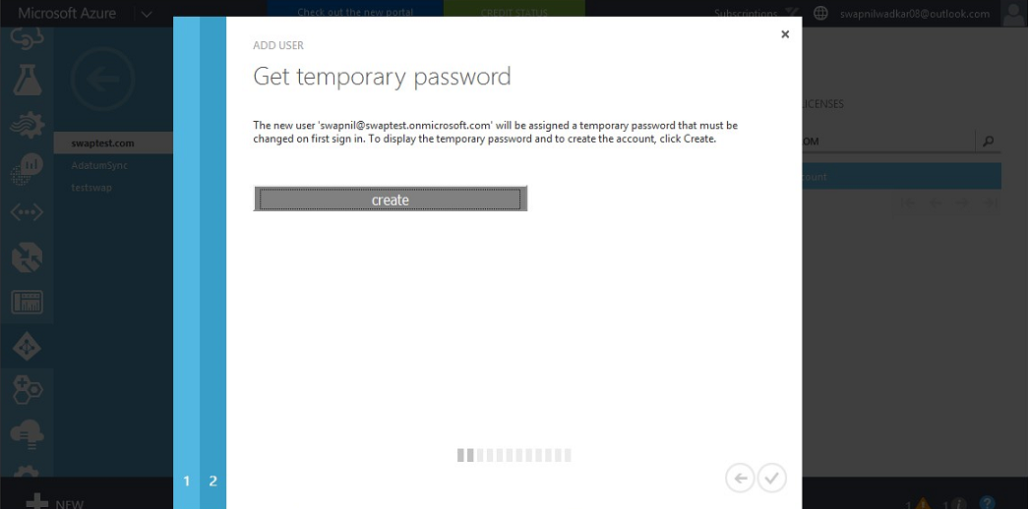

Create a temporary password and save it.

Now login to the DC server or a domain member server, open dsa.msc (Active Directory Users and computers)

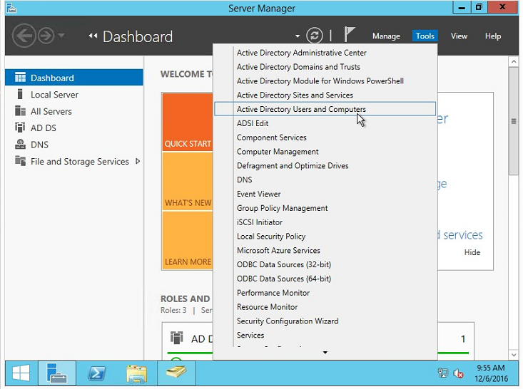

Create some users if you are creating a fresh on-prem AD for test purpose, for existing on-prem AD this step is not needed.

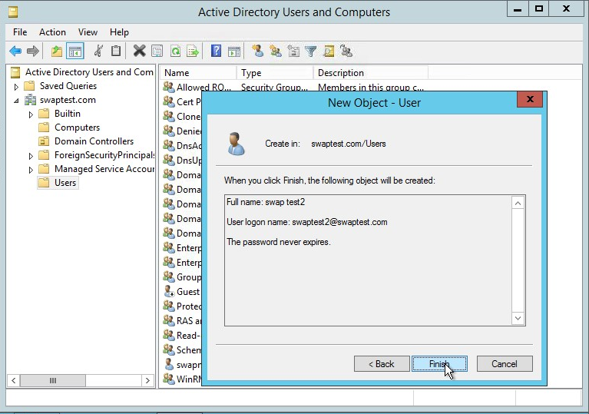

## Downloading and configuring Ad connect

To download the adconnect.msi login to <https://manage.windowsazure.com>

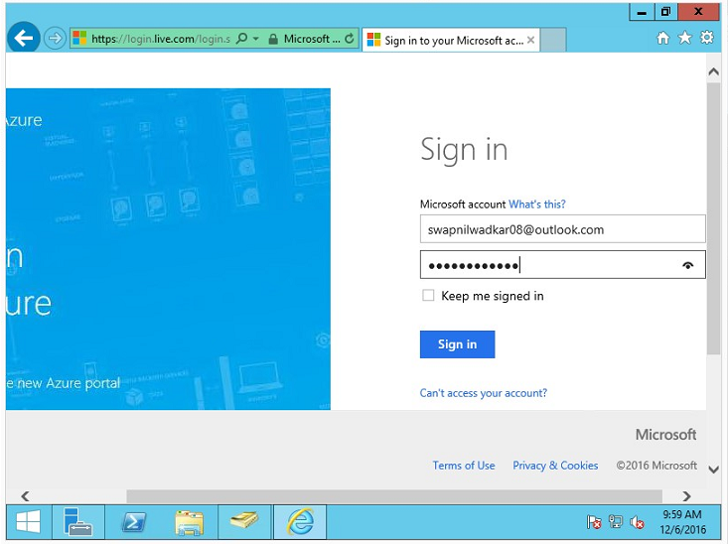

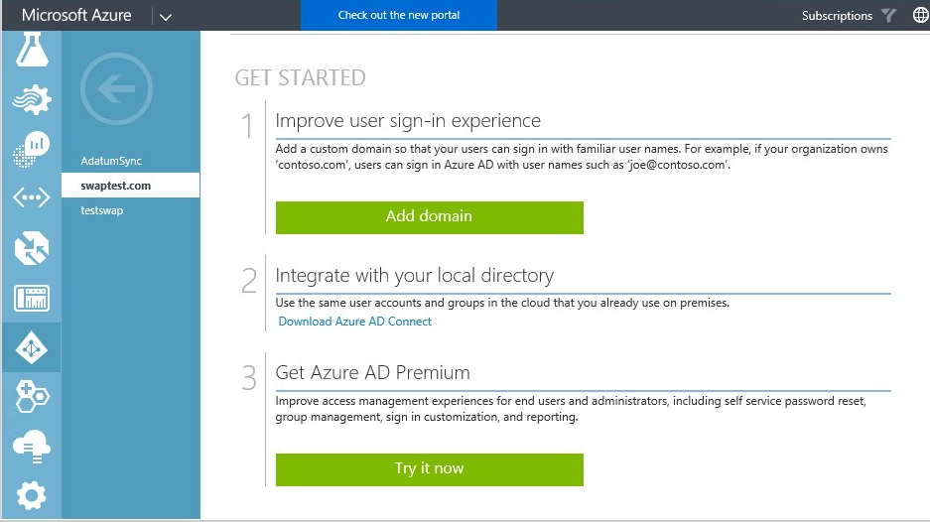

If you own a domain and want to add the domain to Azure. It will improve the user experience and they can login to azure using the organization ID e.g. [abcd@wipro.com](mailto:abcd@wipro.com)

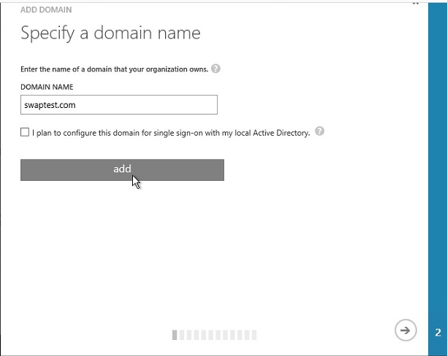

Here if you own a domain, create a TXT record at the domain name registrar of domain service provider and update the DNS setting of the own domain, copy the destination or Points to Address and allow the domain to contact the Azure over the internet.

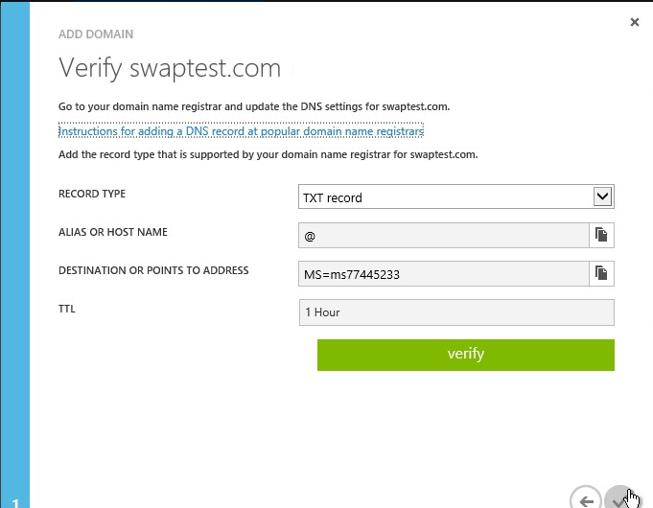

To connect and integrate your local directory, download the Azure AD Connect file in the DC or member server.

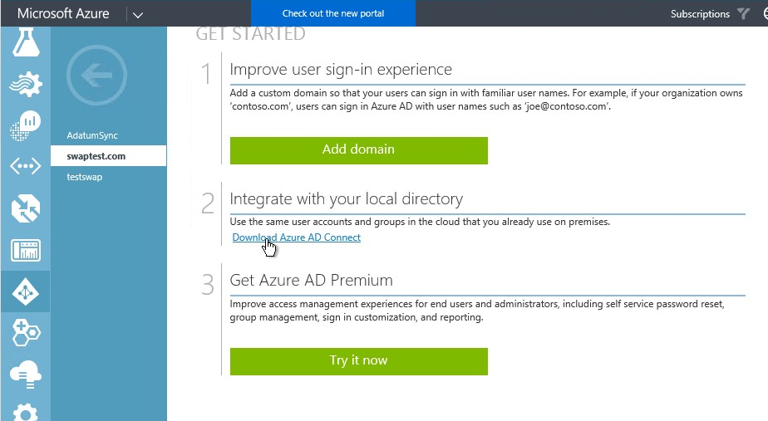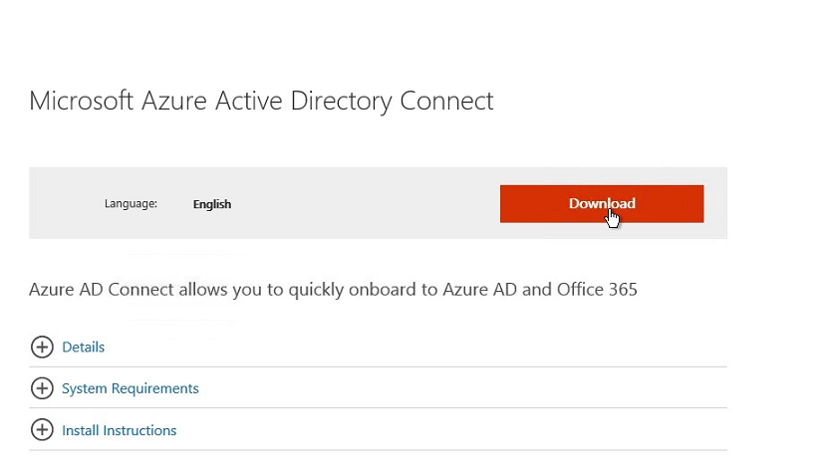

Download and run the setup file.

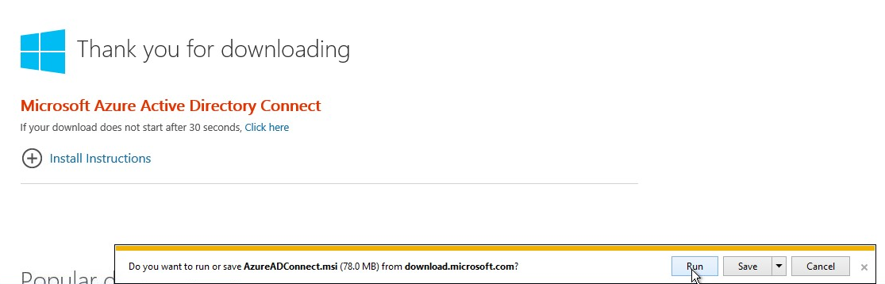

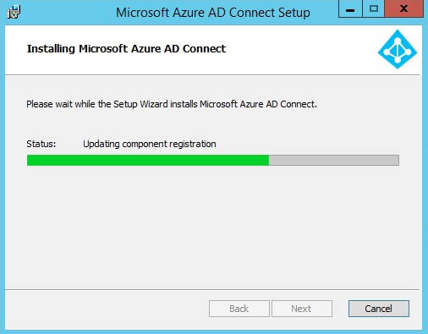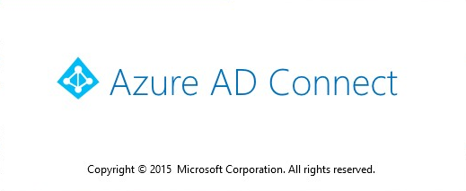

Accept the license term and privacy notice and click next.

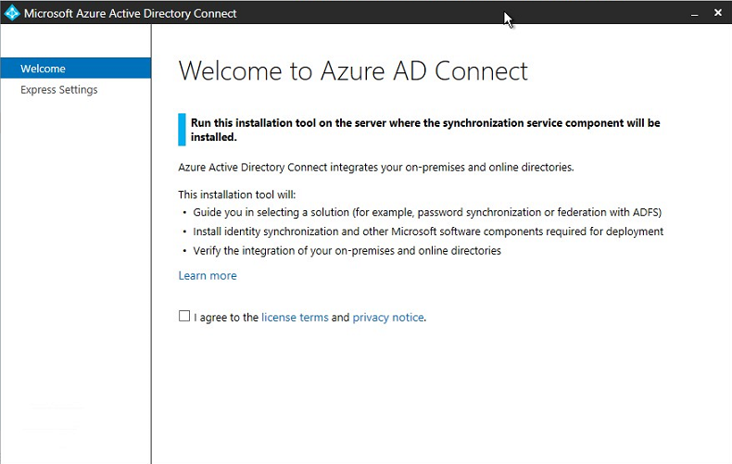

Here you will get two option, Express setting and customize option. For exploring more option, we are selecting custom setting option. Click the “**Customize option**”.

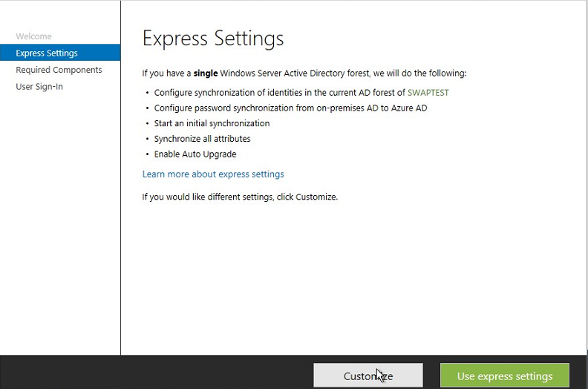

On the **Required Component** page, review the options and then click **Install** to install the synchronization service

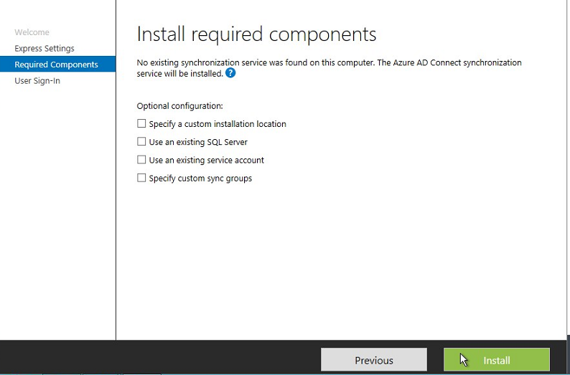

On the **User sign-in** page, verify that **Password Synchronization** is selected, then click **Next**

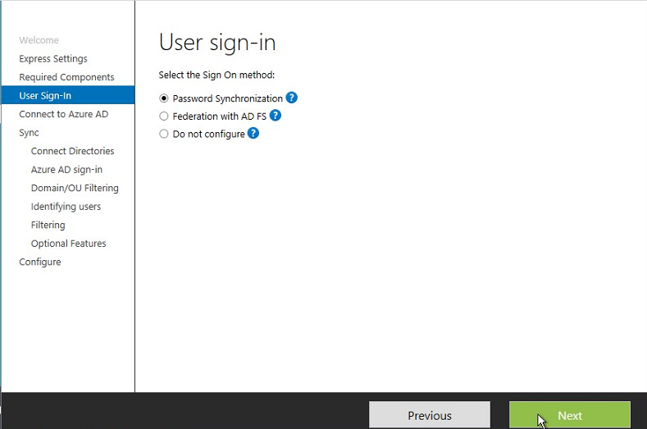

Provide the Sync Account global credential which we have created earlier.

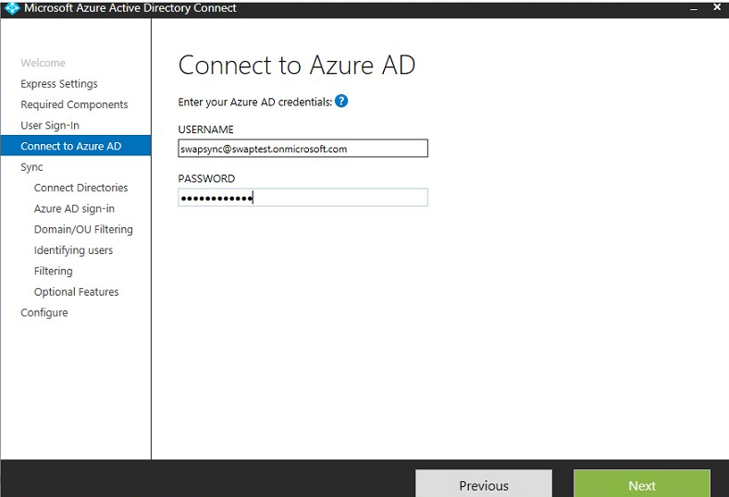

On the **Connect your directories** page, verify that ***your domain forest*** is selected, under username select the admin account of the AD forest and provide the password and click **Add directory** and click next. Since Domain administrator will have all the access in the domain, azure will create a LDAP account with only the necessary access to sync on-prem and Azure AD and will not save the Domain Admin password.

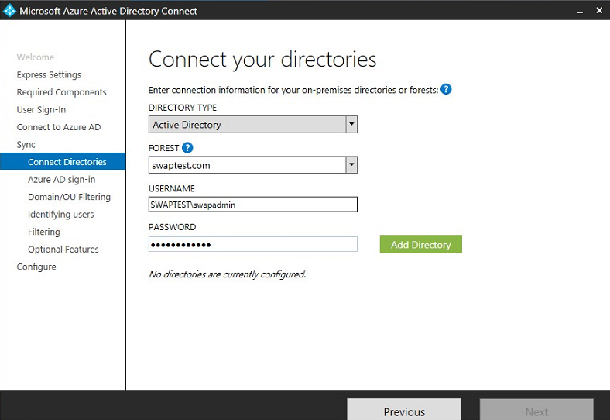

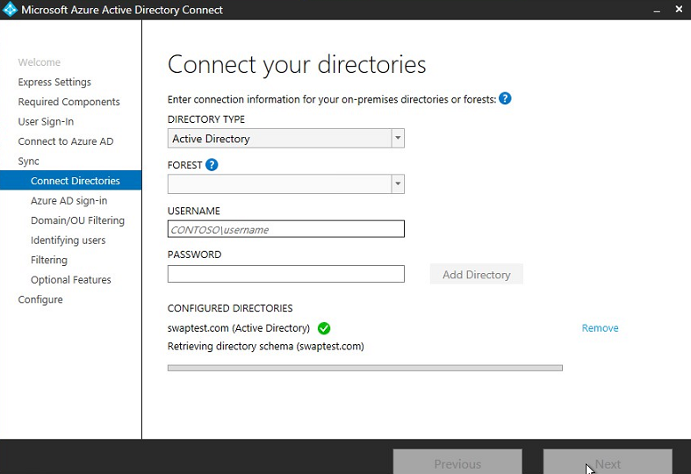

Verify that under Configured Directories, *your domain* is listed and then select the checkbox **Continue without any verified domains** and click **Next**.

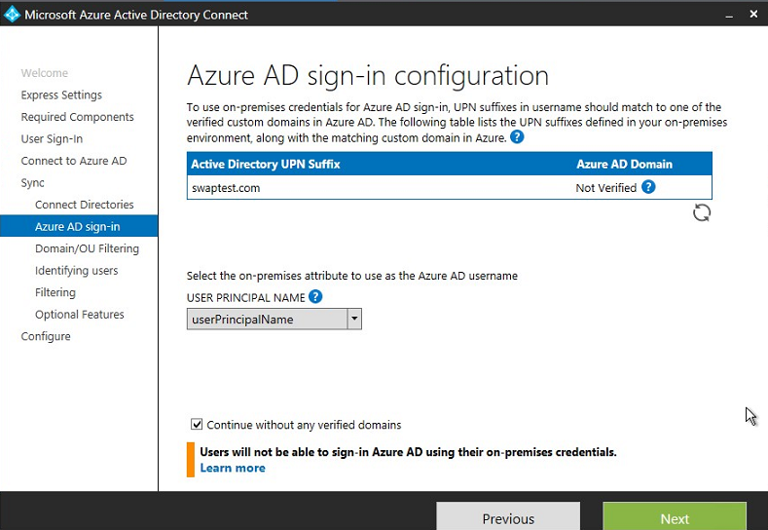

On the **Domain and OU filtering** page, select the **Sync selected domain** **and OUs** check box, expand the **domain** entry, clear all not required check boxes with exception of the one containing the user accounts, groups and service accounts, organization unit & click **Next.**

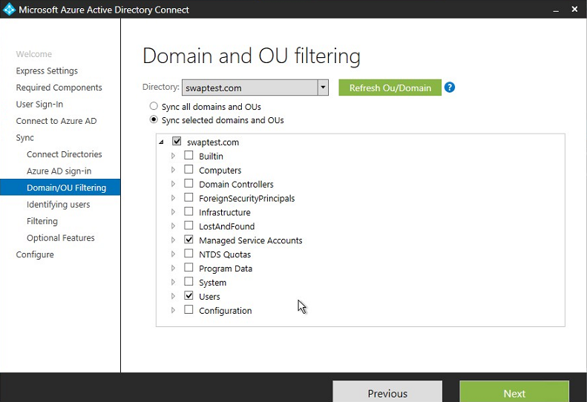

On the **Uniquely identifying your users** page, verify that Users are represented only once across all directories is selected, and then click **Next**.

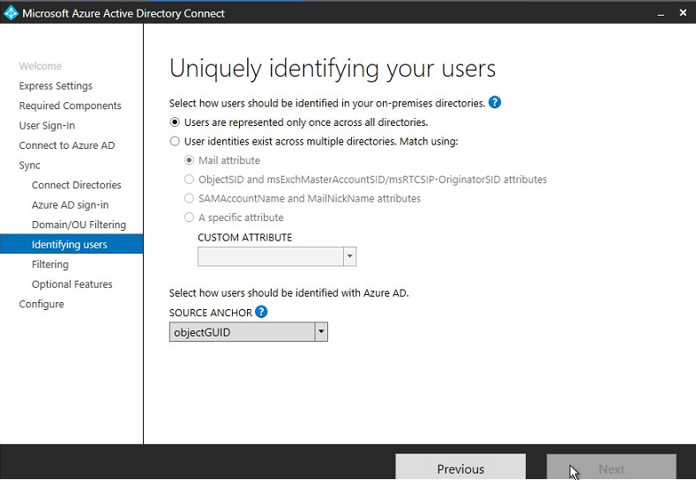

On the Filter users and devices page, verify that **synchronize all users and devices** is selected then click **Next**.

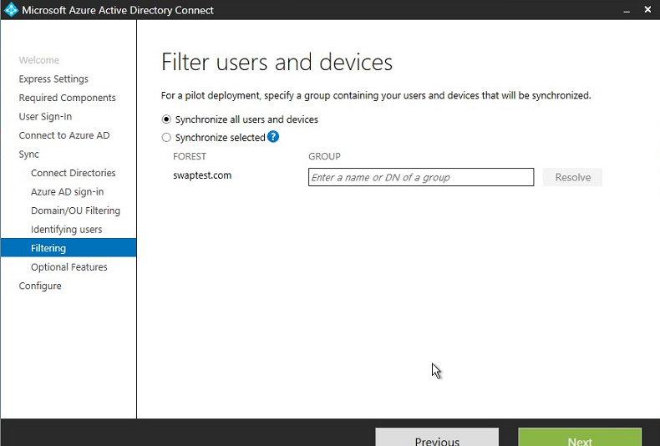

On the **Optional Features** page, verify that Password synchronization is selected. If you need to allow the **Password write-back** to be enabled on this directory (Password writeback allows you to configure your cloud tenant to write passwords back to you on-premises Active Directory), select the check box and click Next.

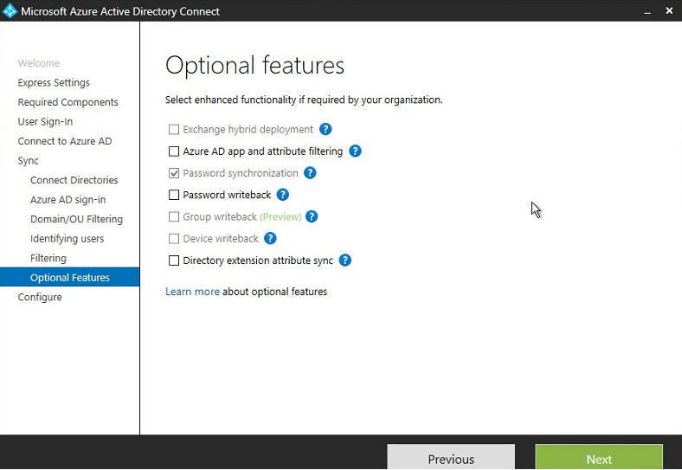

On the **Ready to configure** page, verify that **Start the synchronization process when configuration completes** is selected to start the sync from domain to Azure.

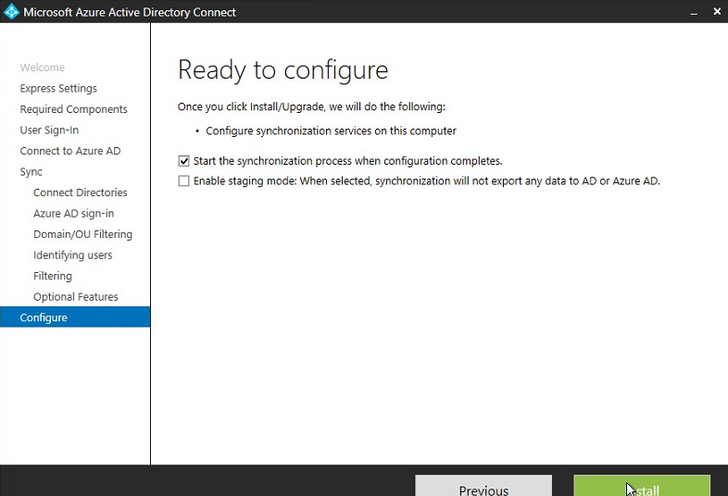

Once the configuration is completed select exit.

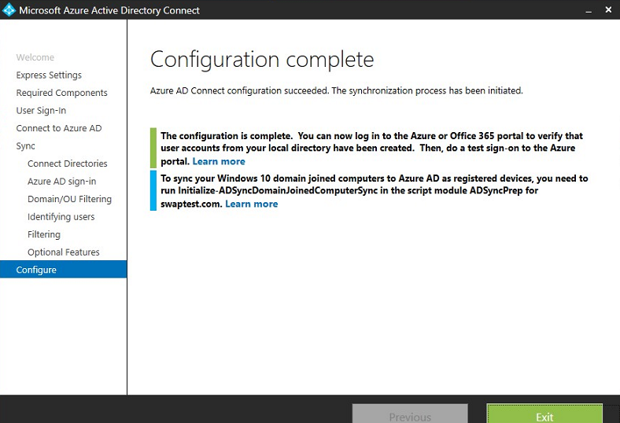

Once the AD synchronization is completed, you can see all the users and accounts are synchronized with Azure AD.

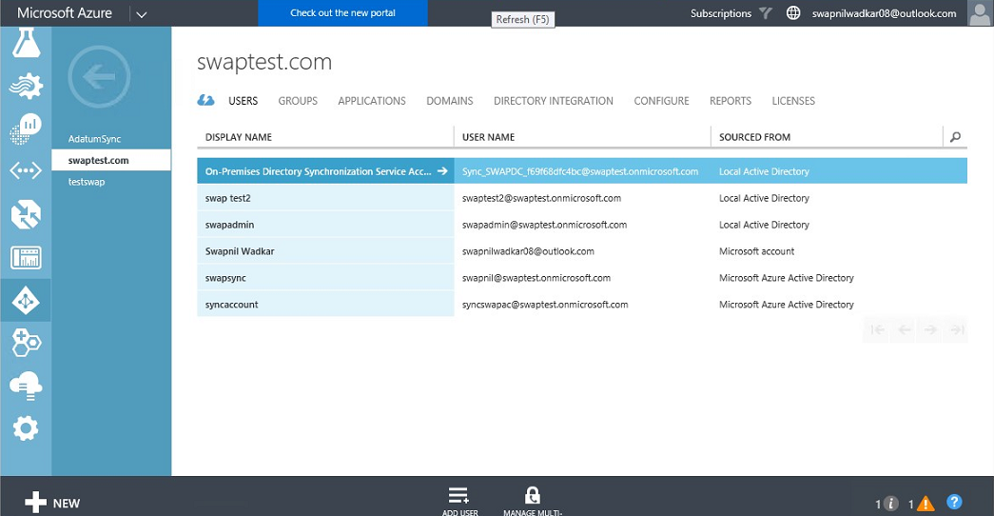

To check the synchronization is happening or not, let’s take a user migrated to Azure AD. Currently the work info is blank.

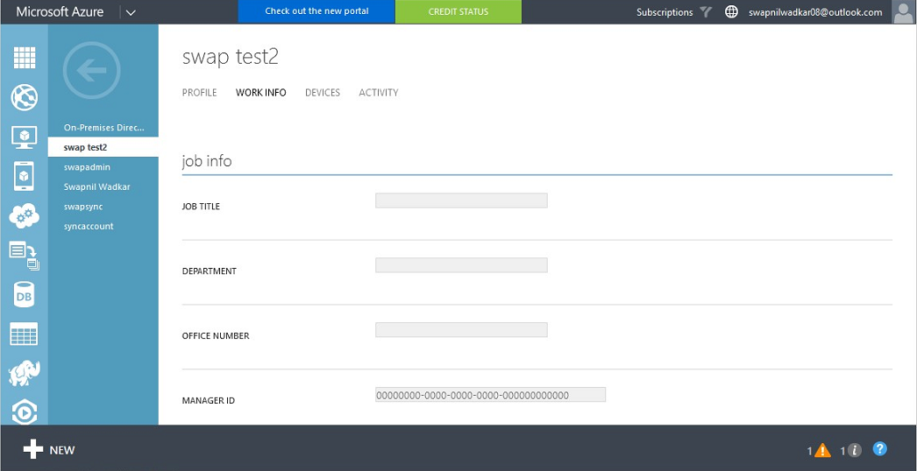

Let’s update the Office info in on-prem AD for a user and click apply and ok.

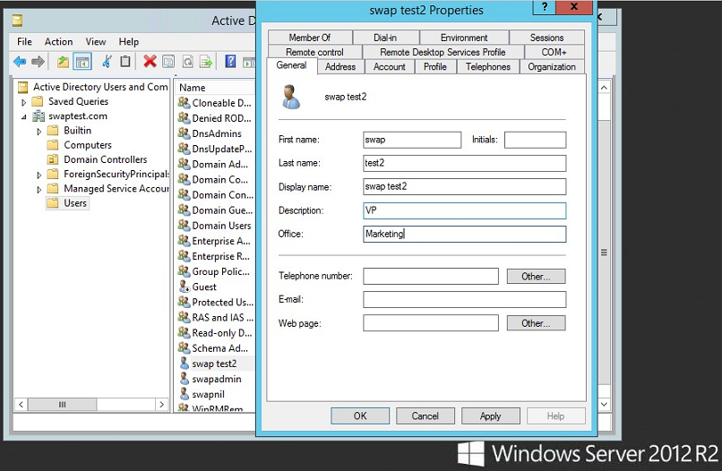

Now open the Windows Powershell with Run as Administrator.

To display the current configuration settings for synchronization with Azure AD.

Run the command: **Get-ADSyncScheduler**

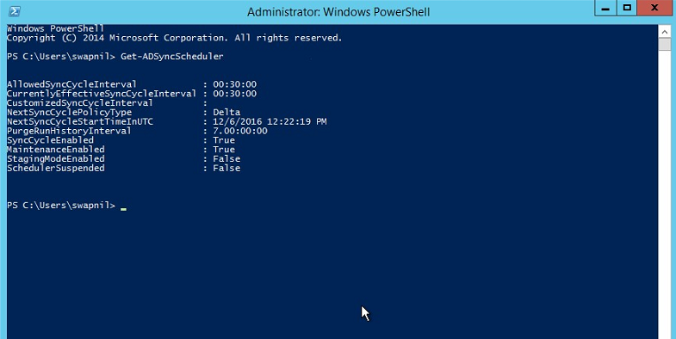

Then type the command to initiate the synchronization and wait until synchronization completes before proceeding.

Command: **Start-ADSyncSyncCycle –PolicyType Delta**

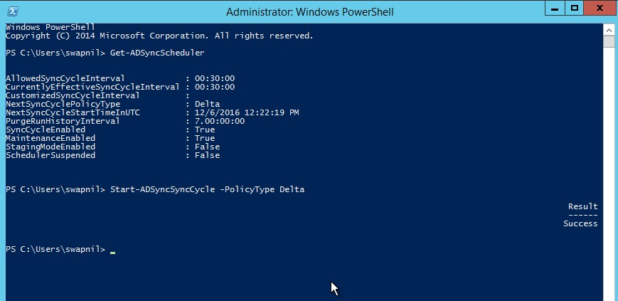

You can see the synchronization has happened and Office field is filled as per the on-prem AD modification.

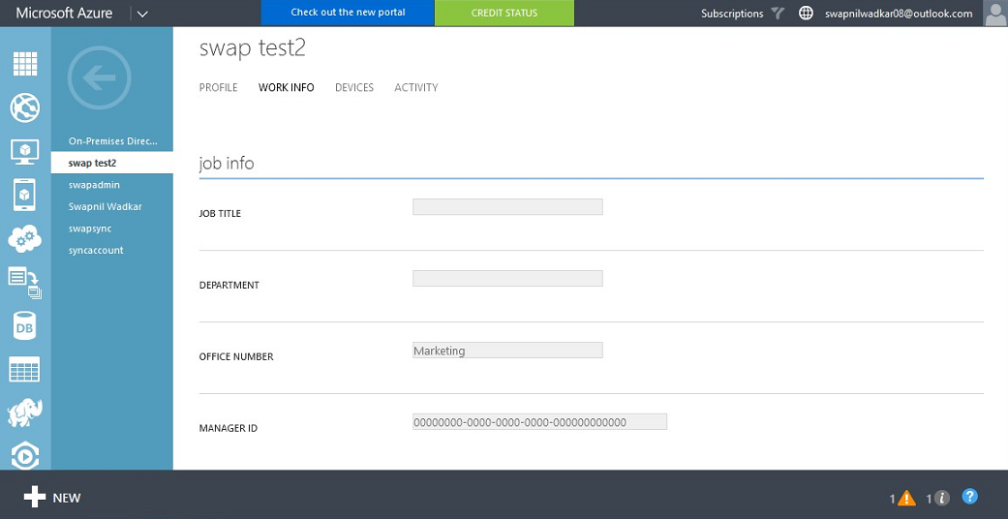

# Powershell Commands:

**Commands**:

Get-Module –ListAvailable;

Import-Module ADSync;

Get-ADSyncConnector;

Get-ADSyncConnectorTypes;

Get-ADSyncGlobalSettings

**Power shell Command**

**To initiate ADSyncmanually with delta sync**: Start-ADSyncSyncCycle-PolicyTypeDelta

**To initiate ADSyncmanually with full sync:** Start-ADSyncSyncCycle-PolicyTypeinitial

**To stop sync in progress**: Stop-ADSyncSyncCycle

**To get AAD sync password configuration:**

Get-ADSyncAADPasswordSyncConfiguration

**To get ADSyncconnector status:** Get-ADSyncConnectorRunStatus

**To monitor the sync engine:** Get-ADSyncConnectorRunStatus

# Azure AD connect Upgarde

Download the Azure-ADconnect software from the below location on the DC/member server where you have already installed Azure ADconnect software and start the installation.

<https://www.microsoft.com/en-us/download/details.aspx?id=47594>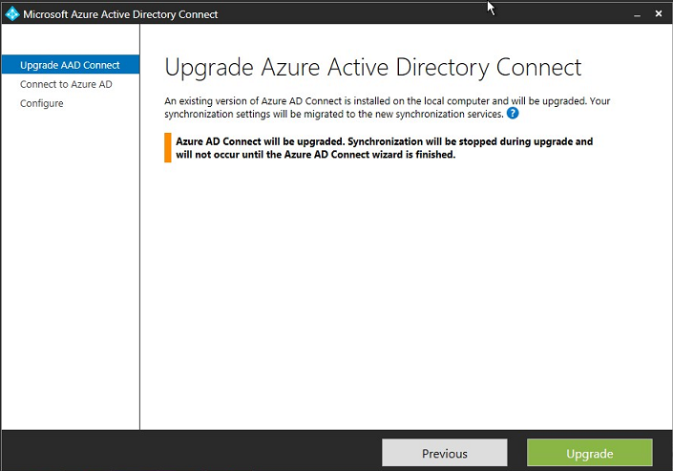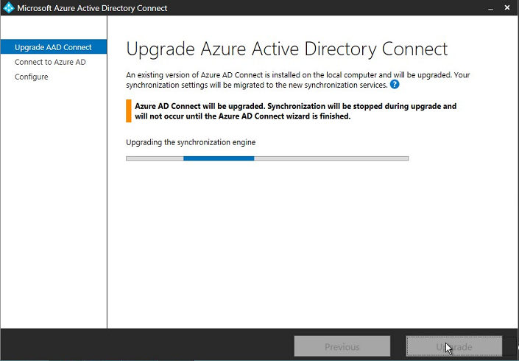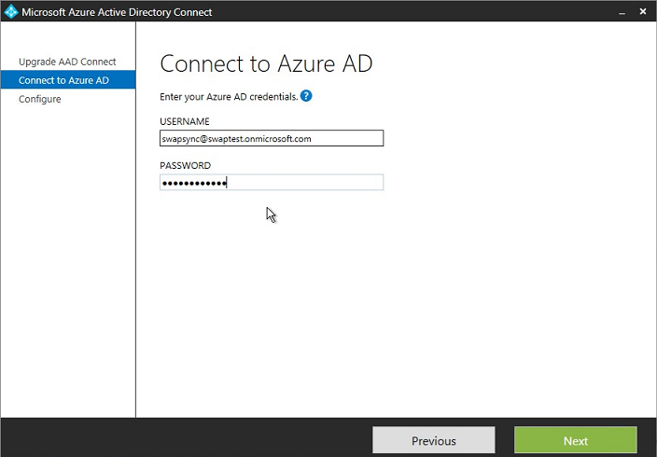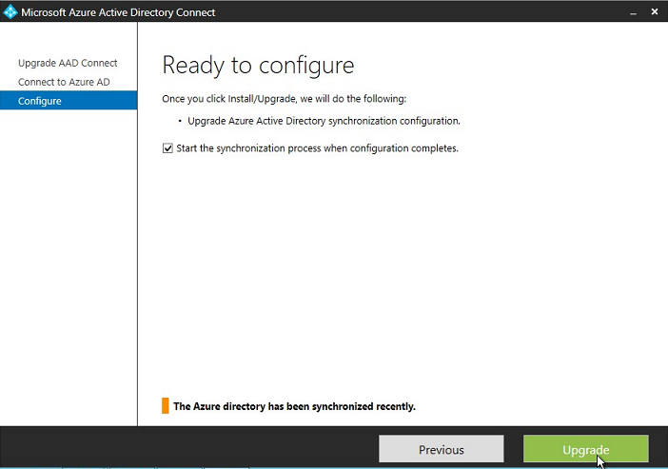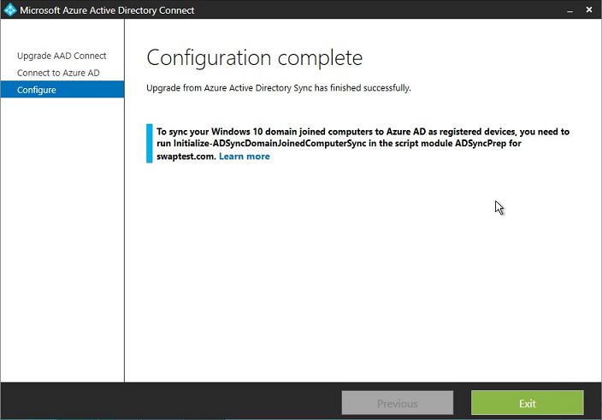

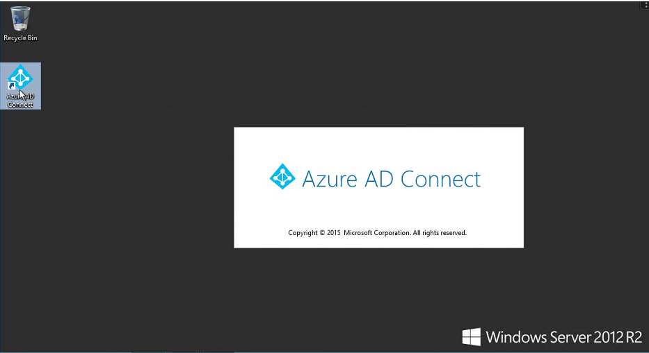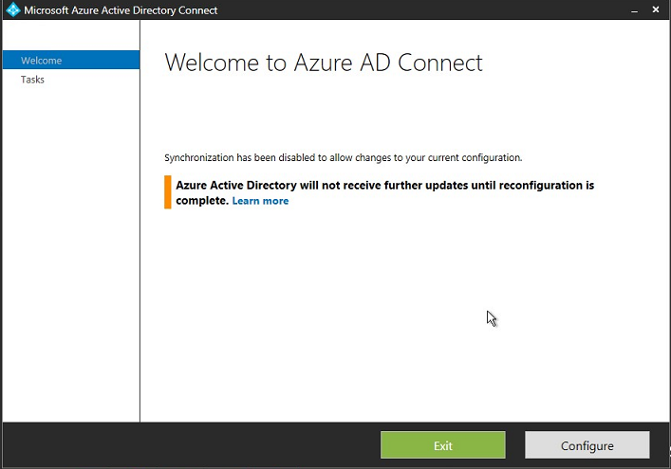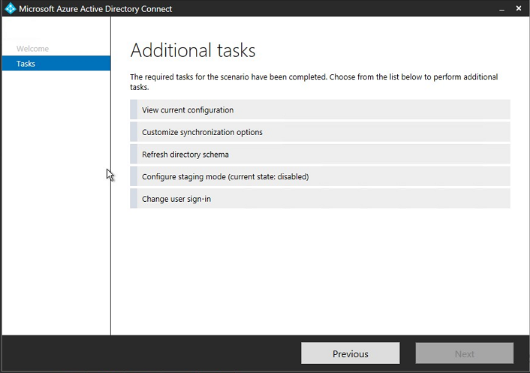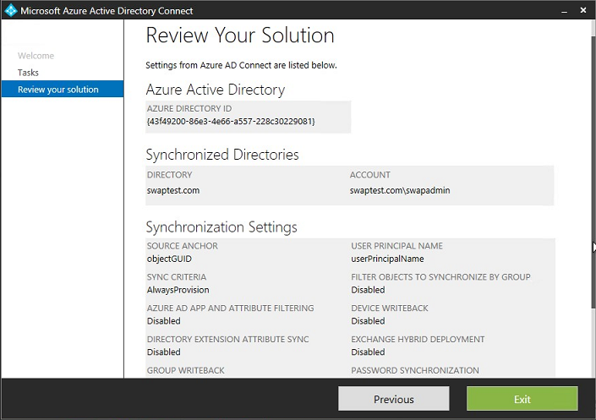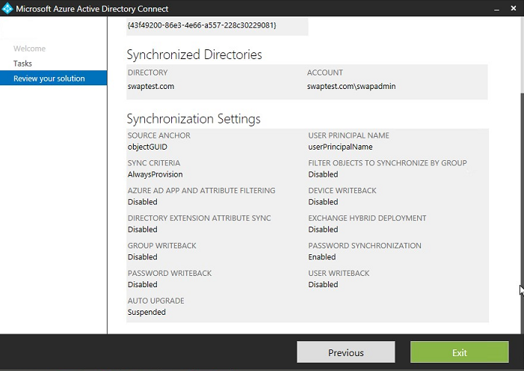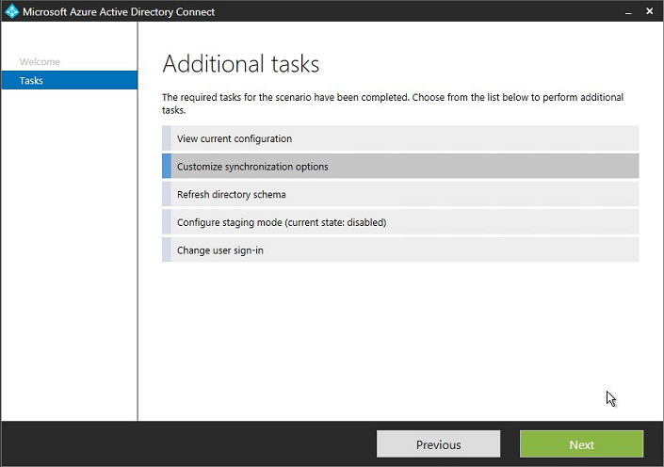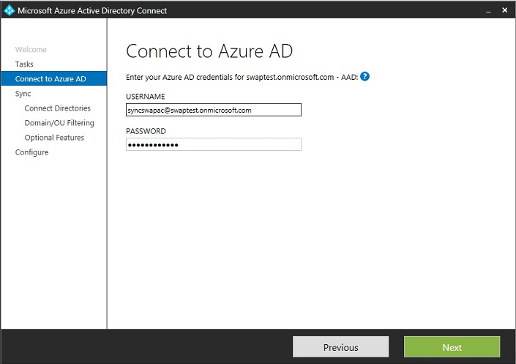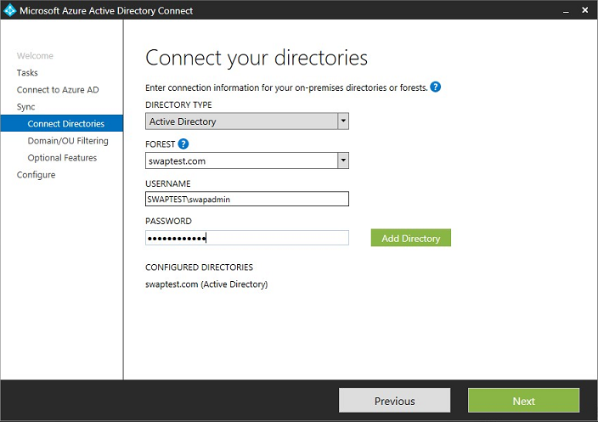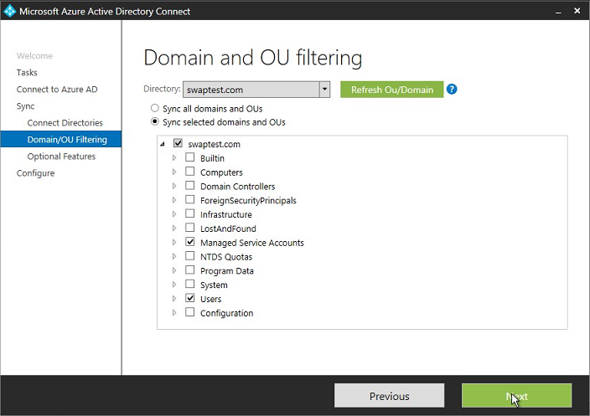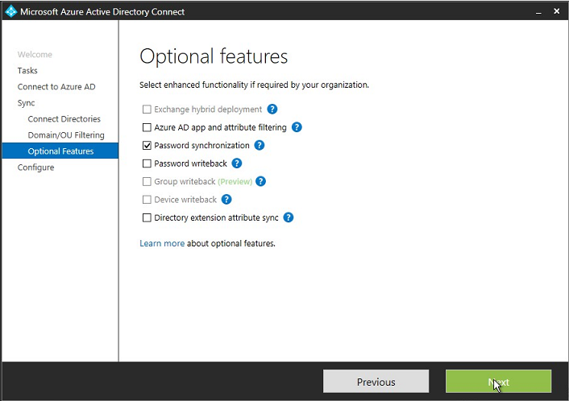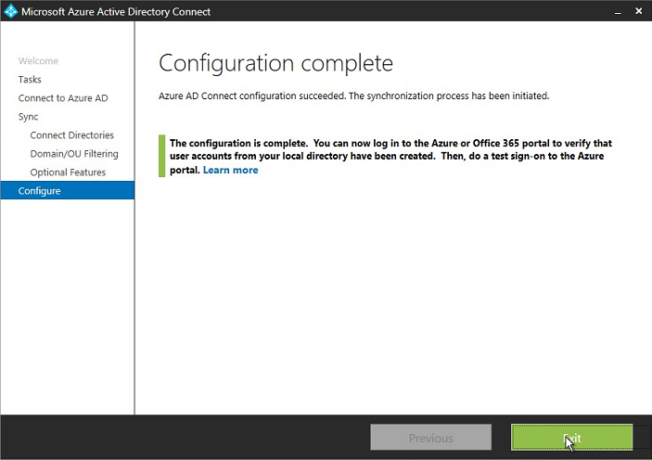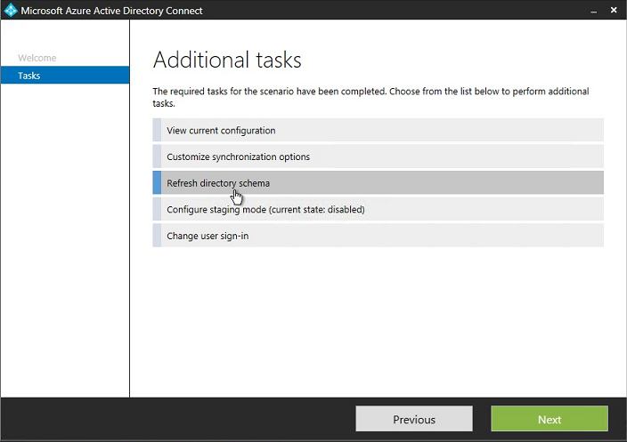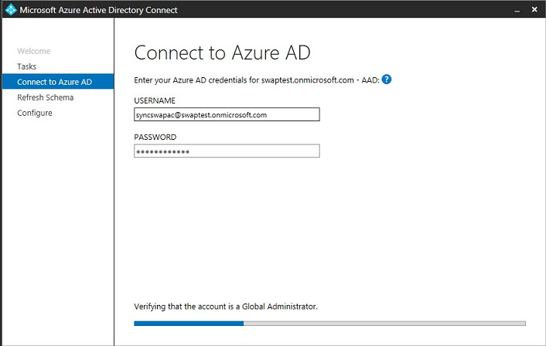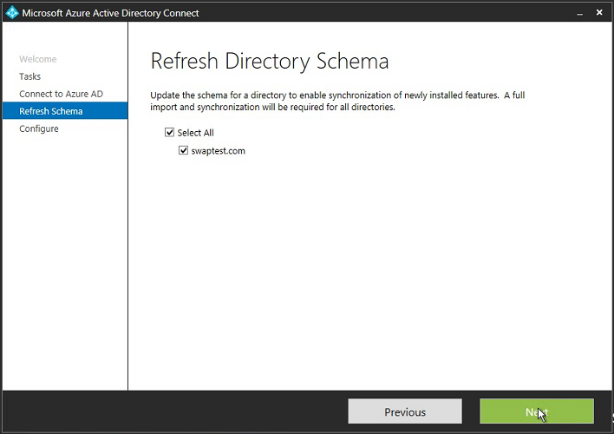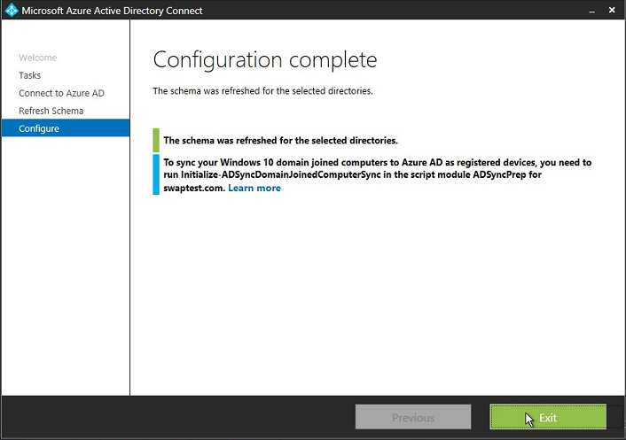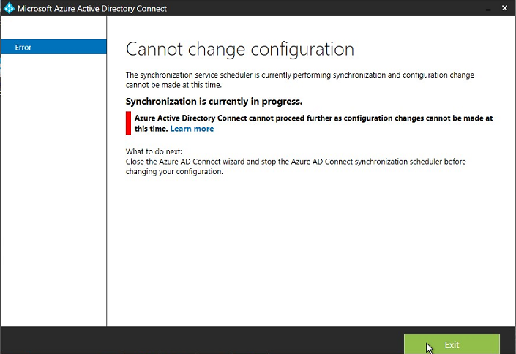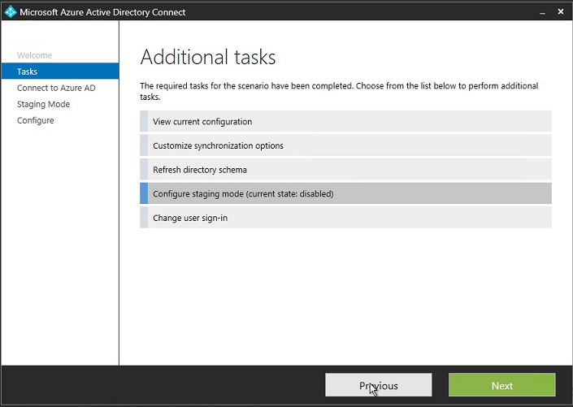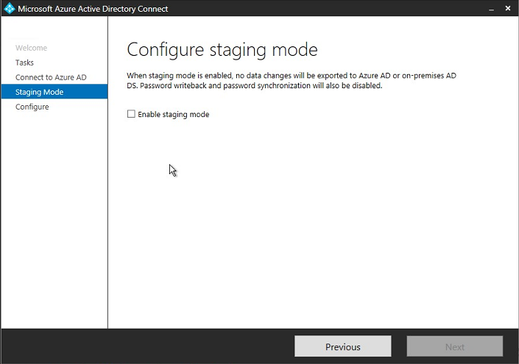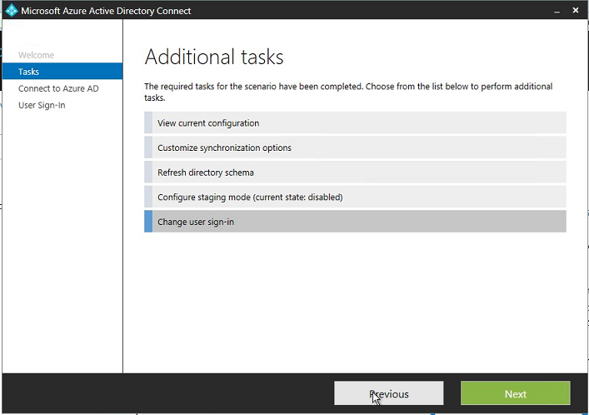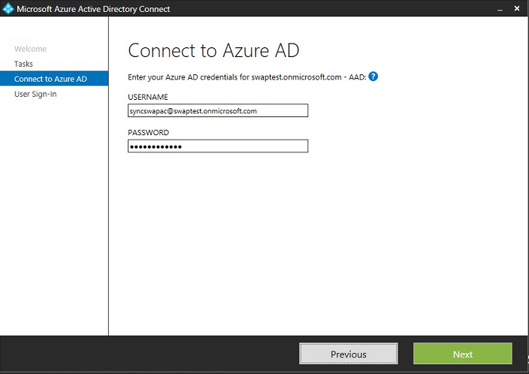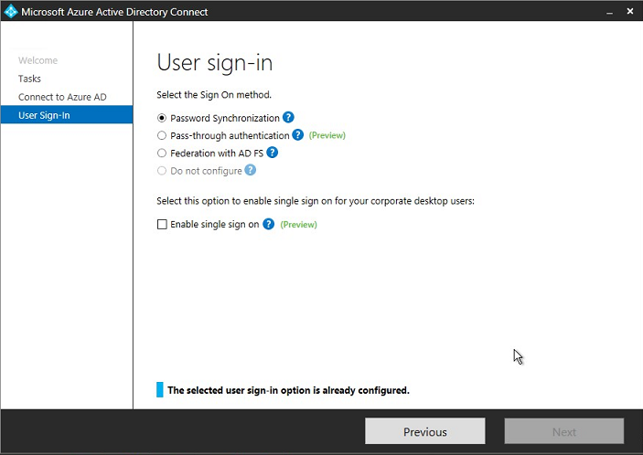

<https://docs.microsoft.com/en-us/azure/active-directory/active-directory-aadconnect-pass-through-authentication>

<https://docs.microsoft.com/en-us/azure/active-directory/active-directory-aadconnect-user-signin#federation-using-a-new-or-existing-ad-fs-in-windows-server-2012-r2-farm>

<https://docs.microsoft.com/en-us/azure/active-directory/active-directory-aadconnect-sso>

# References

https://docs.microsoft.com/en-us/azure/active-directory/active-directory-whatis. (n.d.).

THANKS